

DXC RealTime Projects

AZ-900, DP - 203



June 10, 2022

DXC Technology

[Company address]

Name: Sivarathri Brahmaiah

Reg No: dxc262ab1228

**Project1 Name: Smart Vehicles**

Date: 10-06-2022

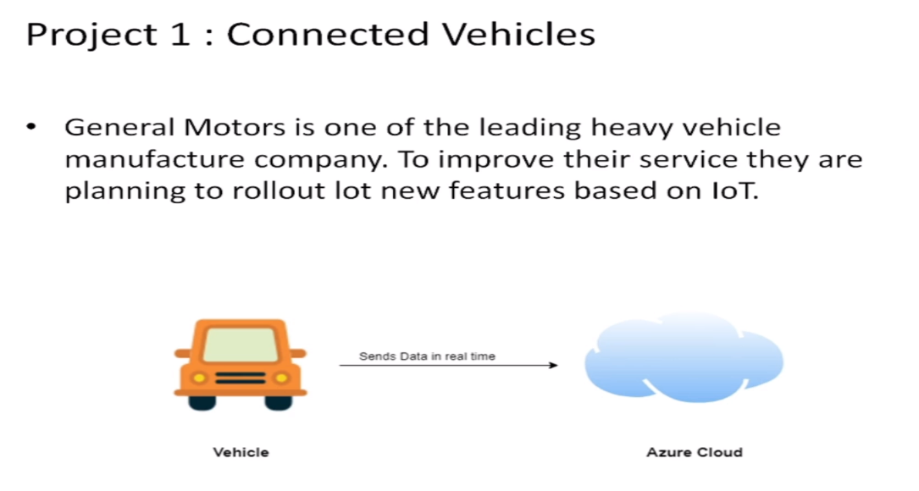

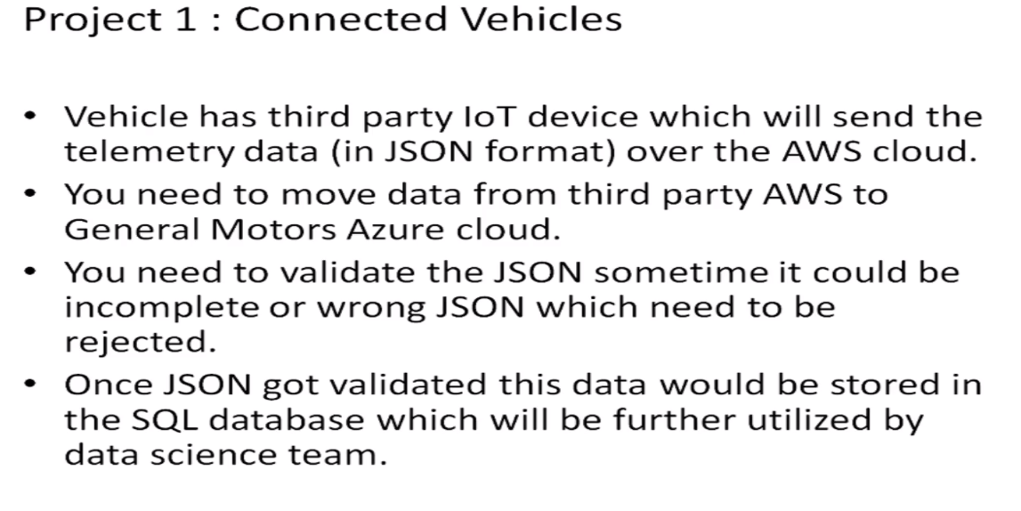

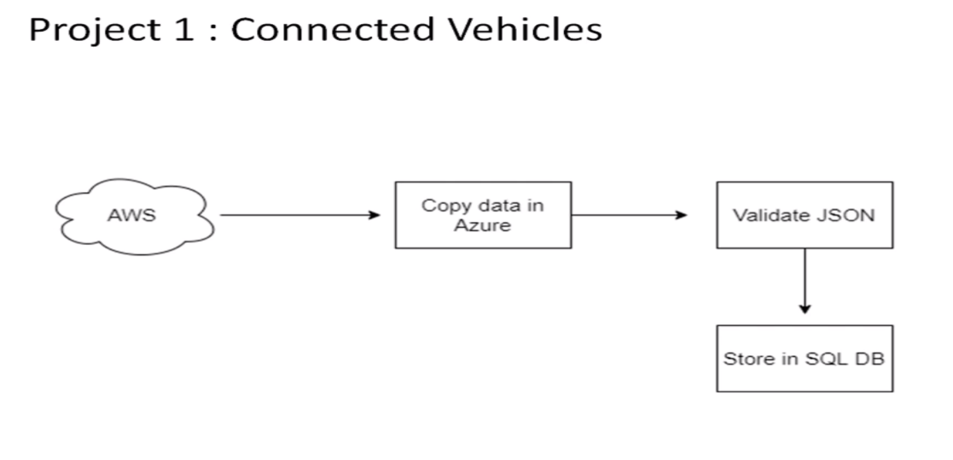

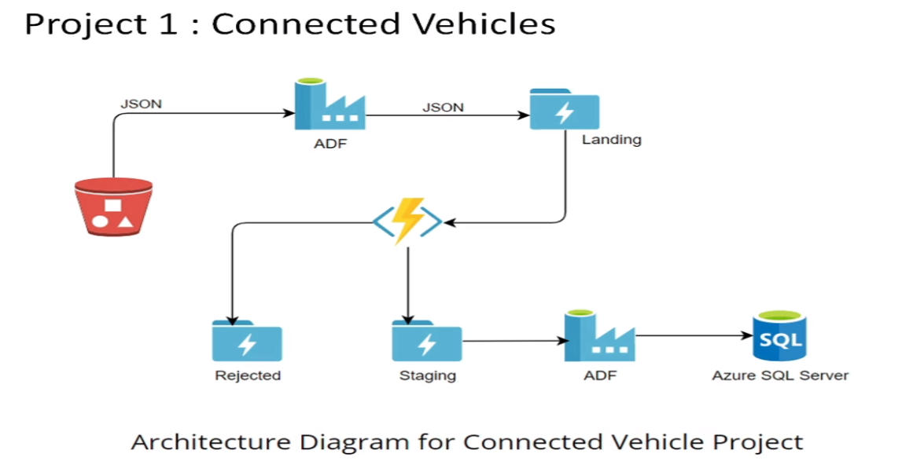

**Step1:**

At first we need to create the data factory in the azure.

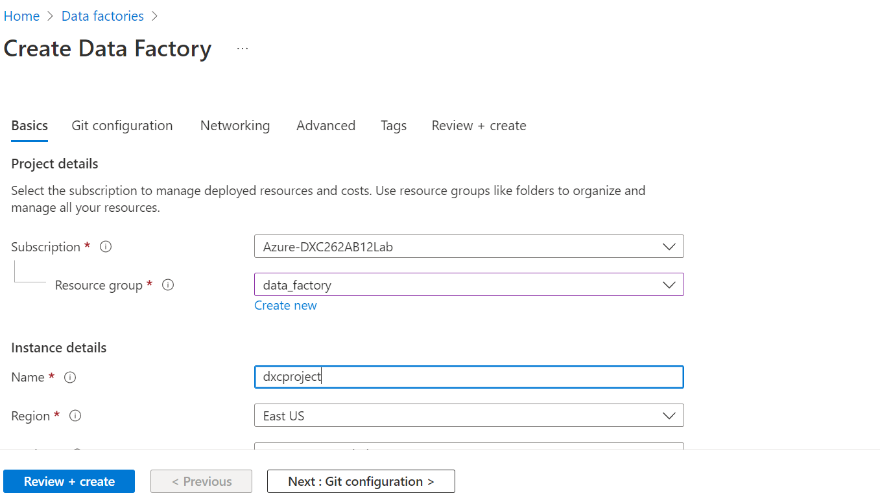

**Step2:**

After that click on the review + create button then deployment will be come which is shown in below figure.

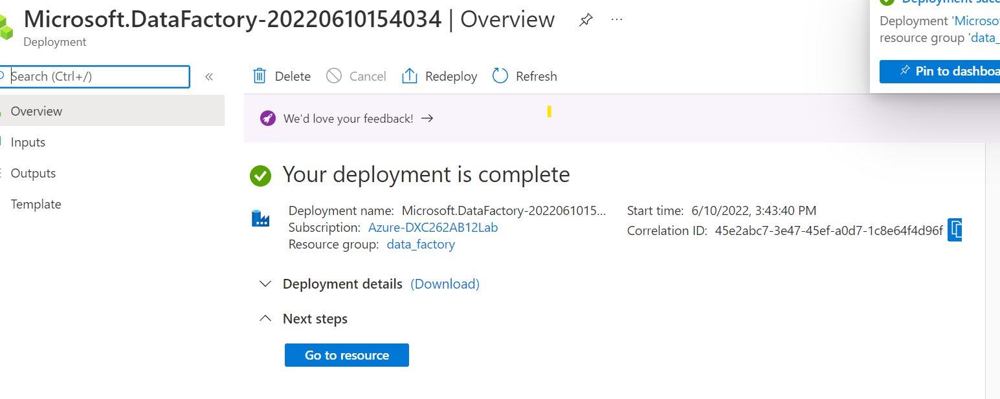

**Step3:**

After successful creation of the deployment open the azure factory studio which is shown in below.

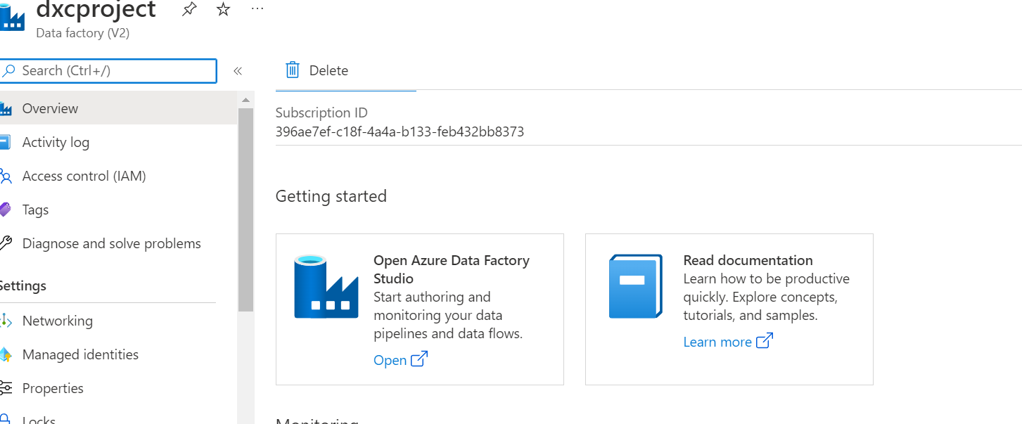

**Step4:**

After opening of the data factory click on the built in copy task, and then click on the ‘Next’ button.

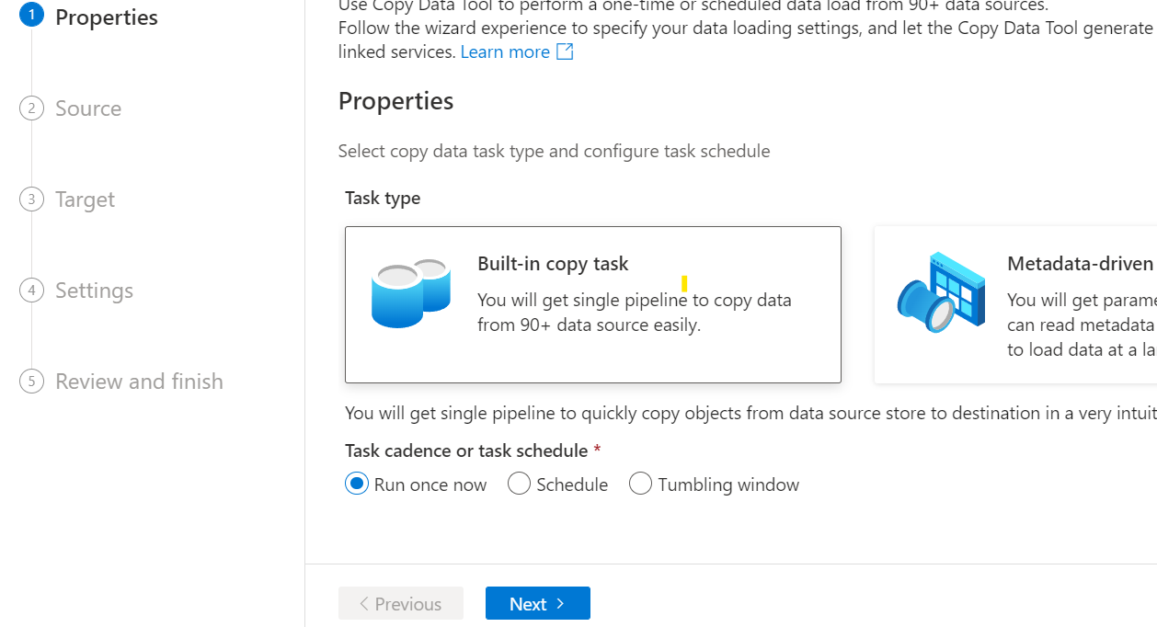

**Step5:**

Here we have to give the connection and we must choose on file and we can enter into another stage.

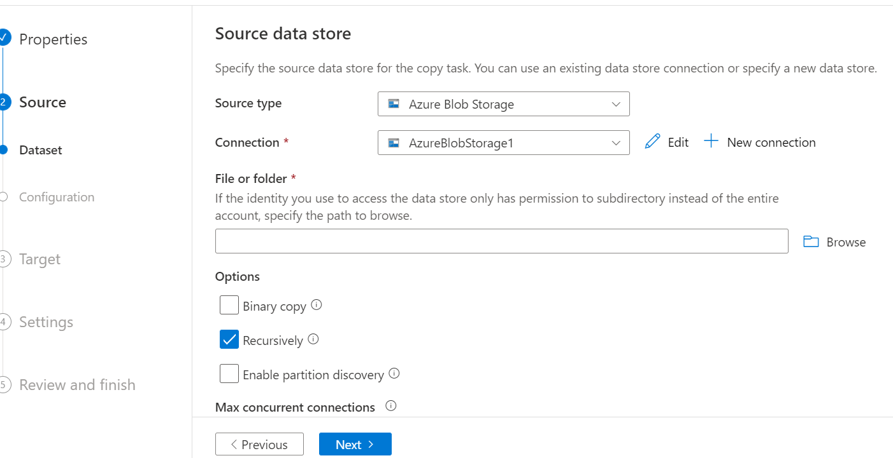

**Step6:**

In file we must select the one file then click on the ‘Next’

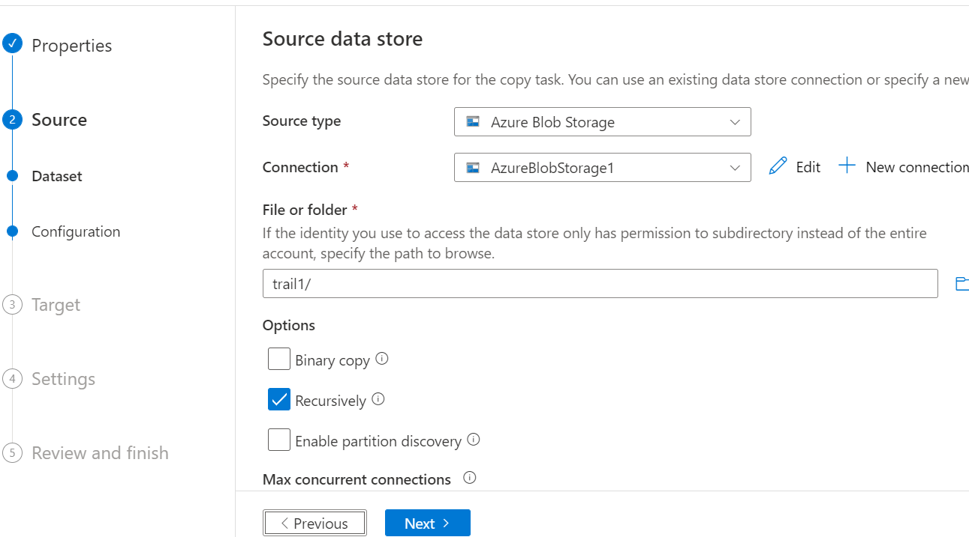

**Step7:**

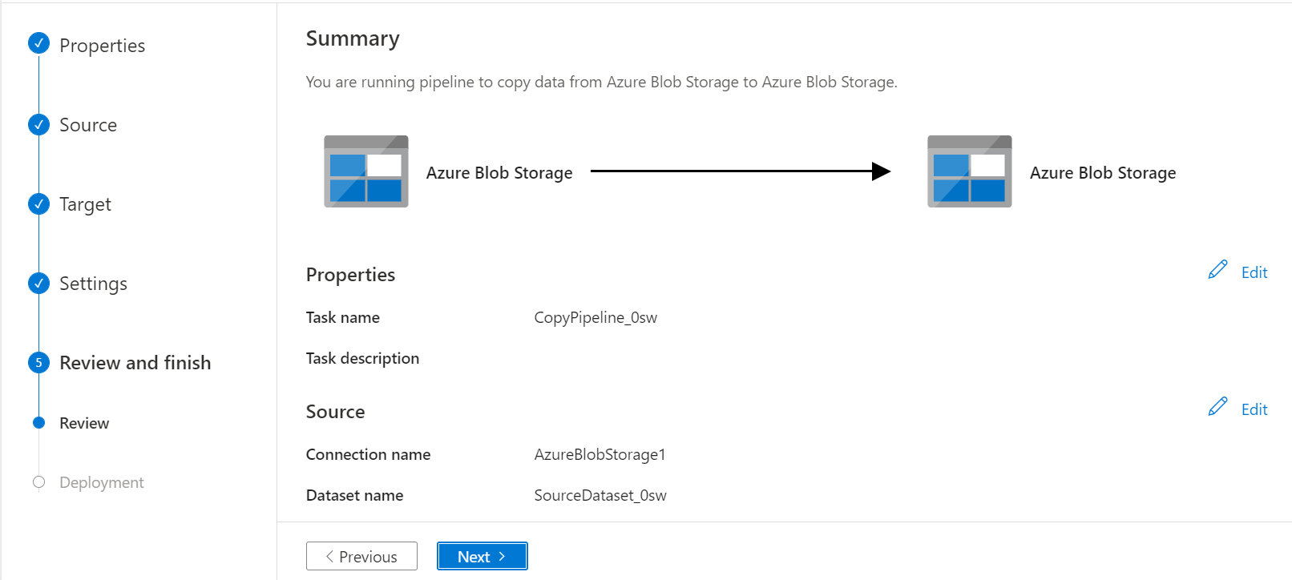After giving all the inputs to the modules finally review will be come which is shown in below.

**Step8:**

After click on the next button then pipe line will be created 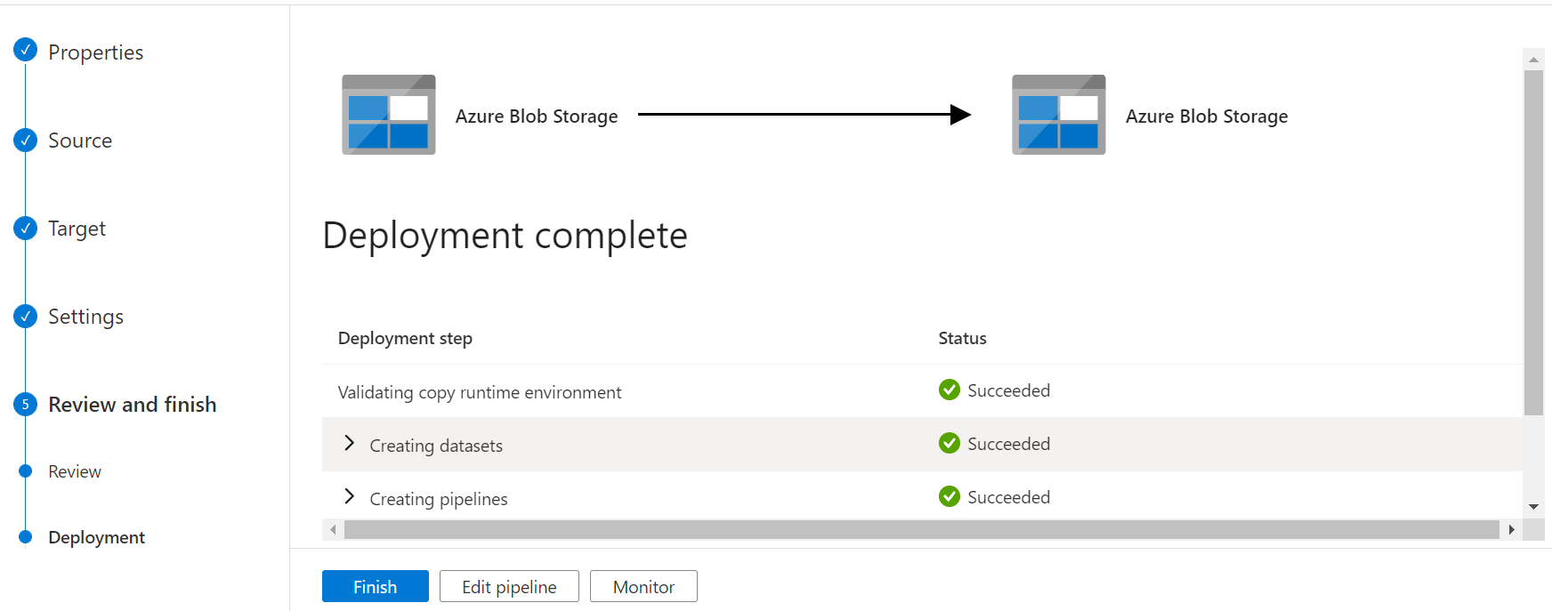**Step9:**

At first we have to create pipe line then go to the add trigger in that we have edit the trigger.

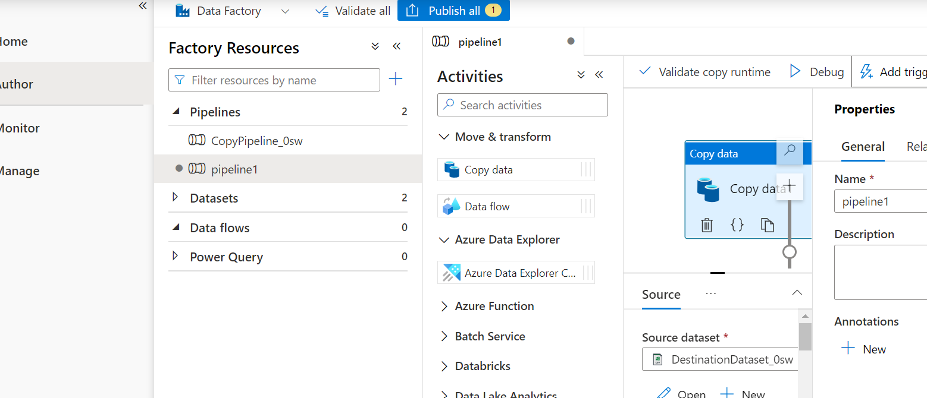

**Step10:**

In manage we have option then go and create the new trigger with occurrence also. Then we can see trigger has created successfully.

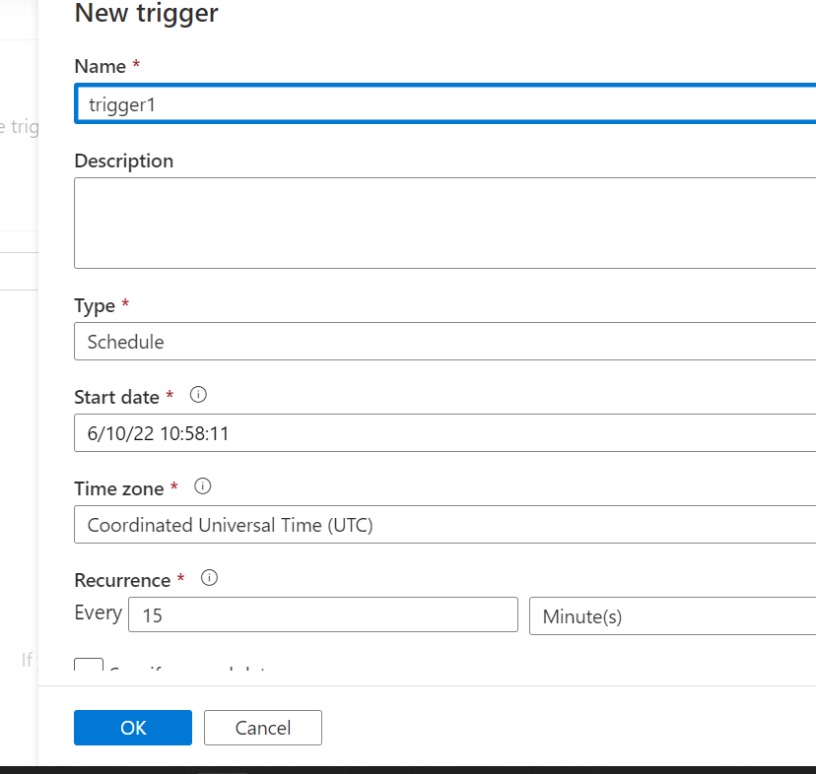

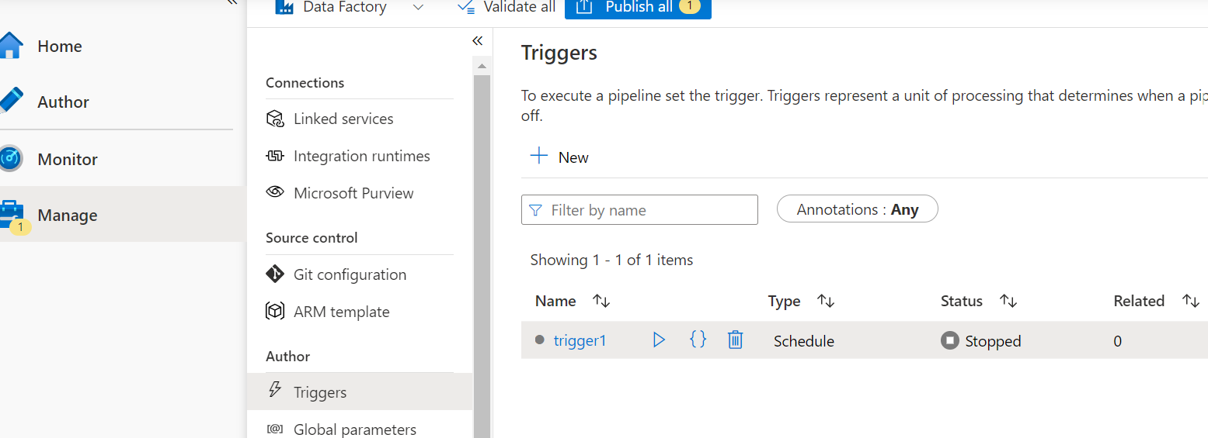

**Step11:**

Go to sql server fill the all necessary fields and you have to set one password.

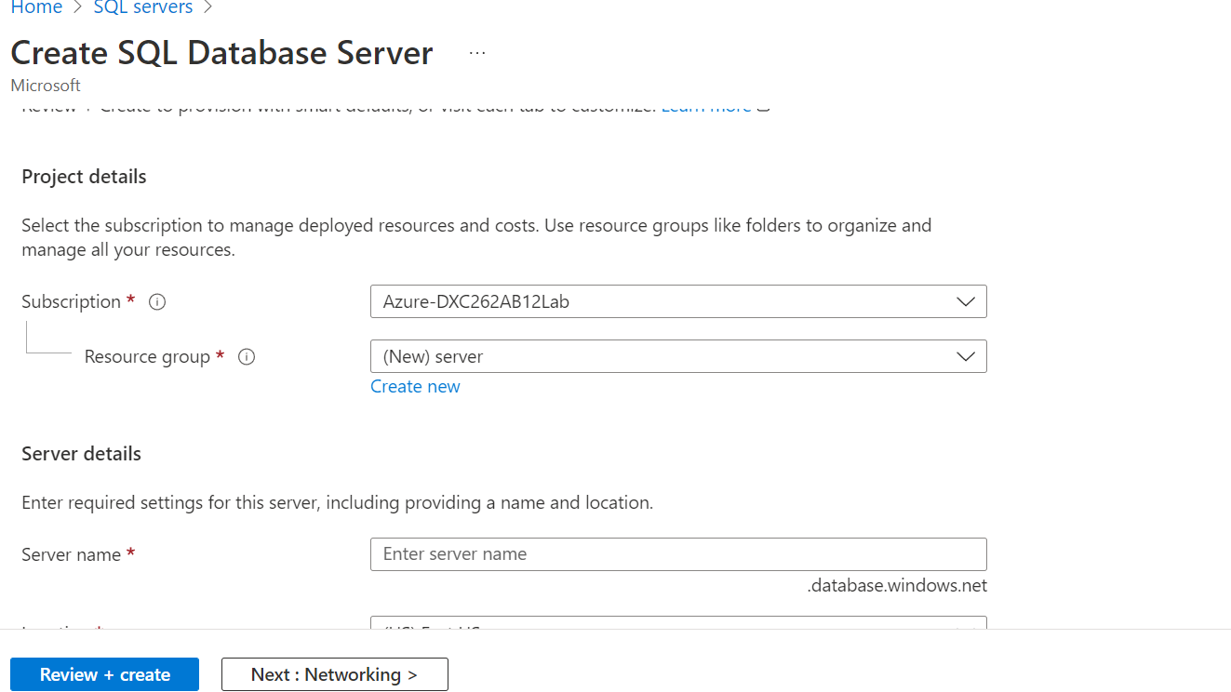

**Step12:**

After creating the sql data base server deployment will be initiated.

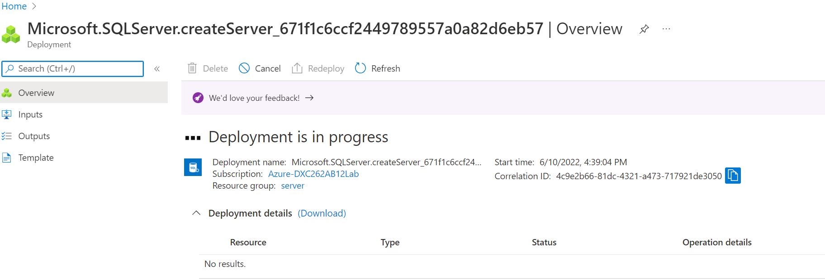

**Step13:**

Then server has been created.

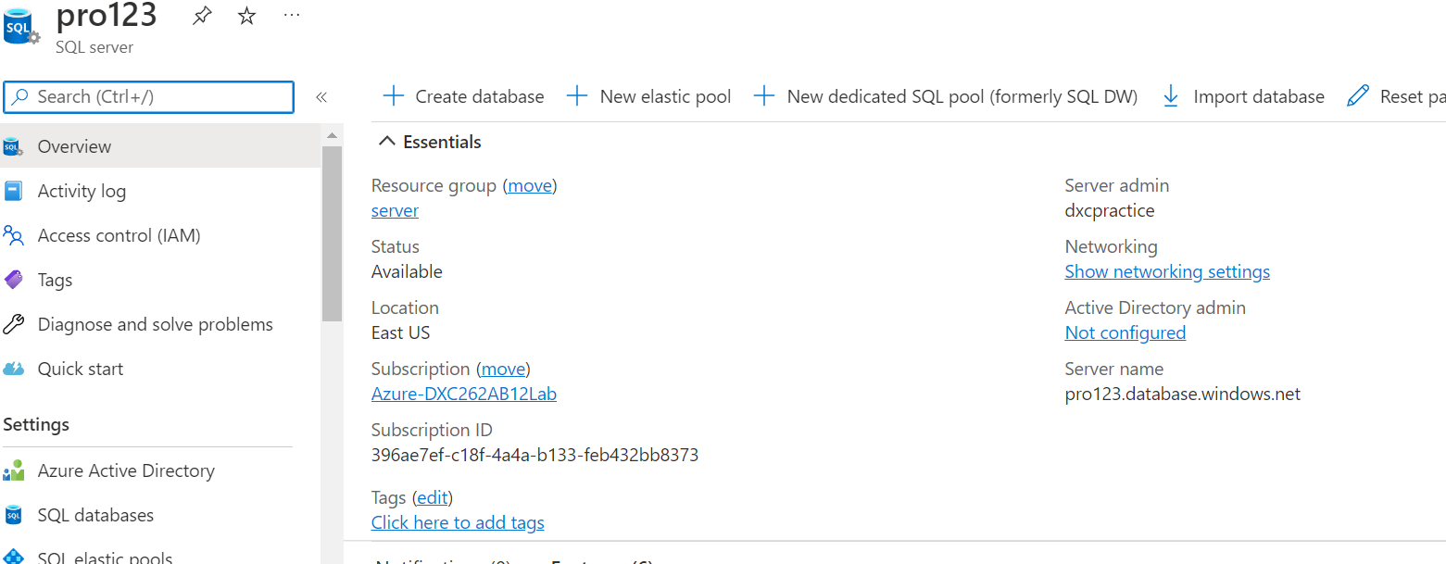

**Step14:**

Similarly we need to create the data base by following above steps.

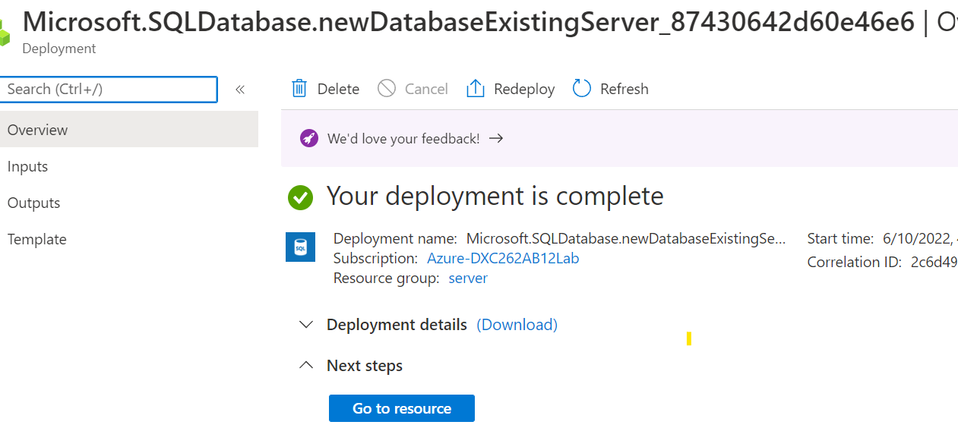

**Step15:**

After creation of the data base, go to the query editor then we have to give the password whatever we had set before.

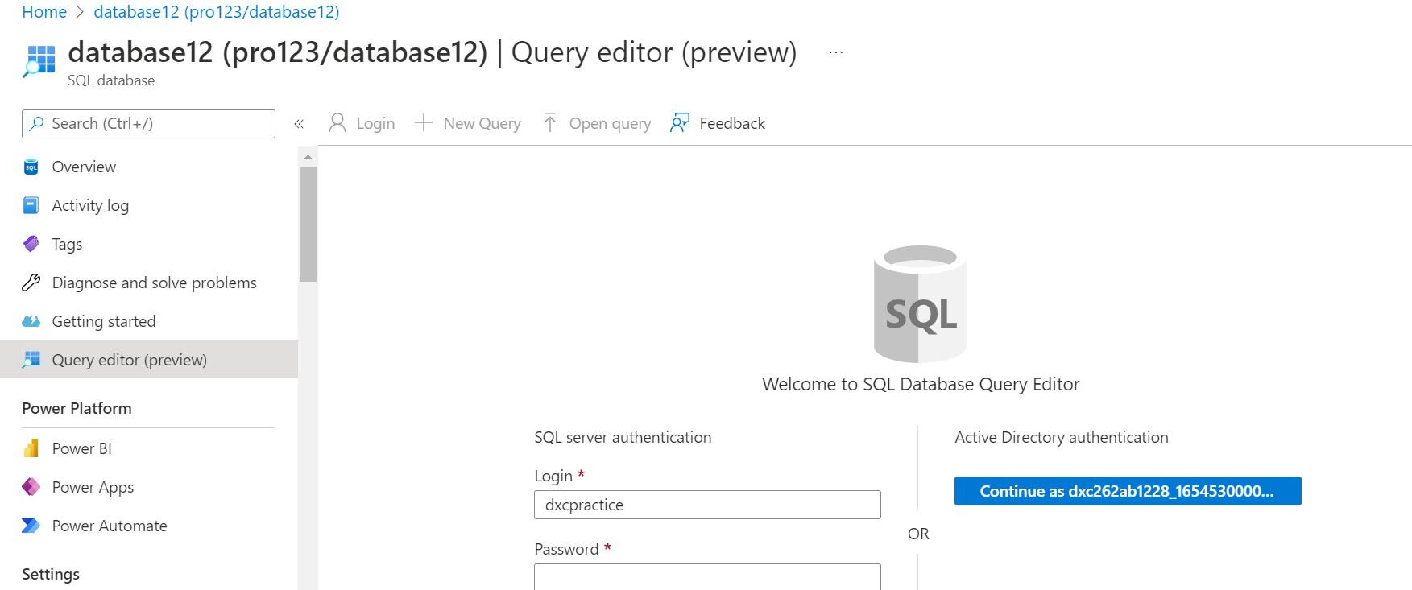

**Result:**

Here we are successfully created the pipeline that will copy the will validate and copy the blob data into SQL database

**Conclusion:**

Azure is the most effective and simple service. With the help of the azure blob data is successfully validated and stored into SQL database

Name: Sivarathri Brahmaiah No

Reg No: dxc262ab1228

**Project2 Name: AP Morgan Data Platform**

Date: 10-06-2022

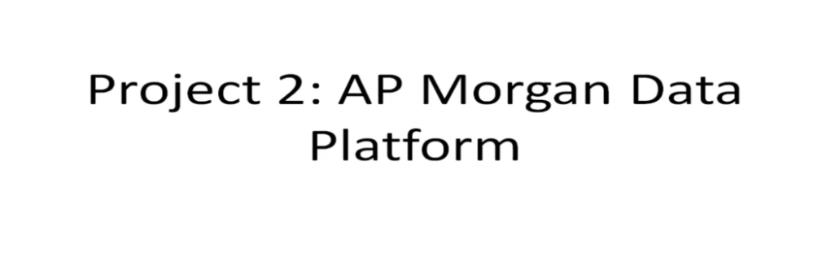

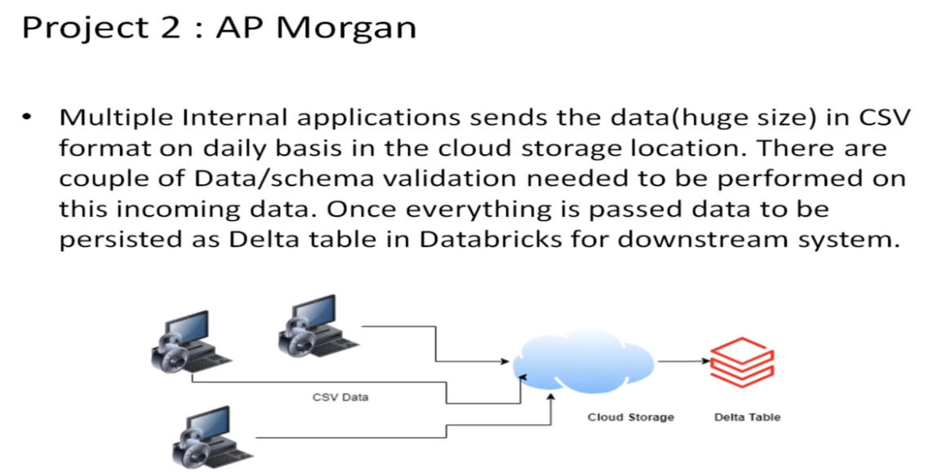

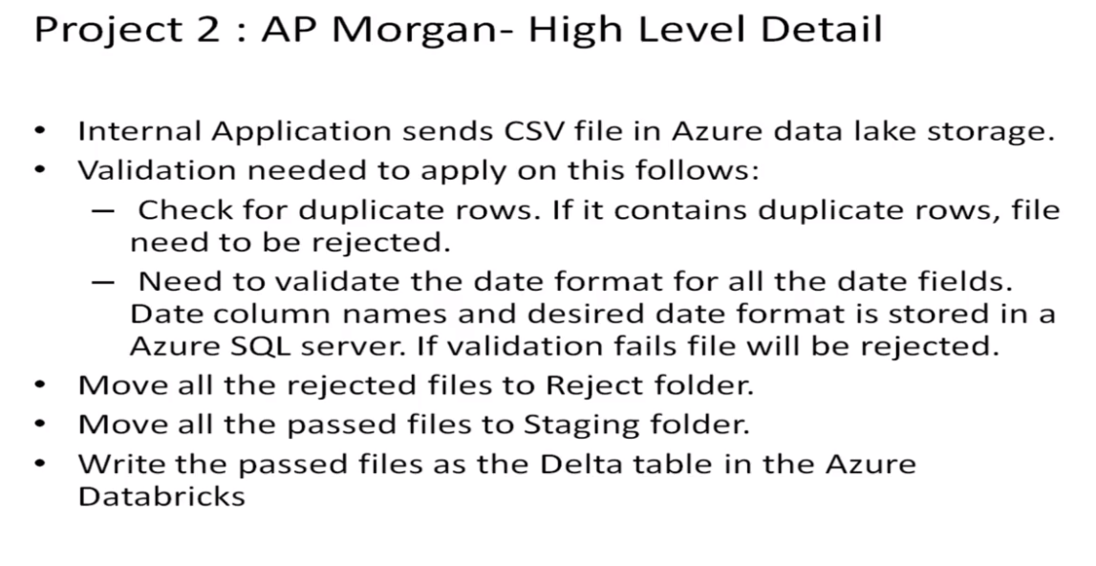

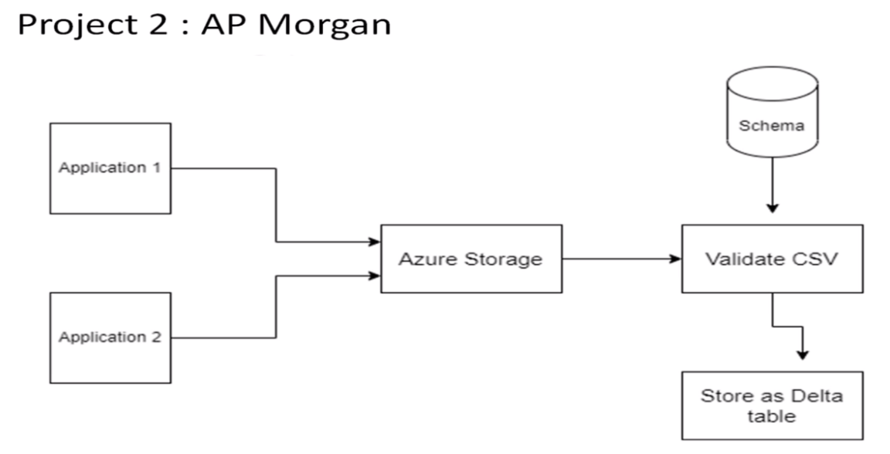

Go to data bricks and create work space for data brick

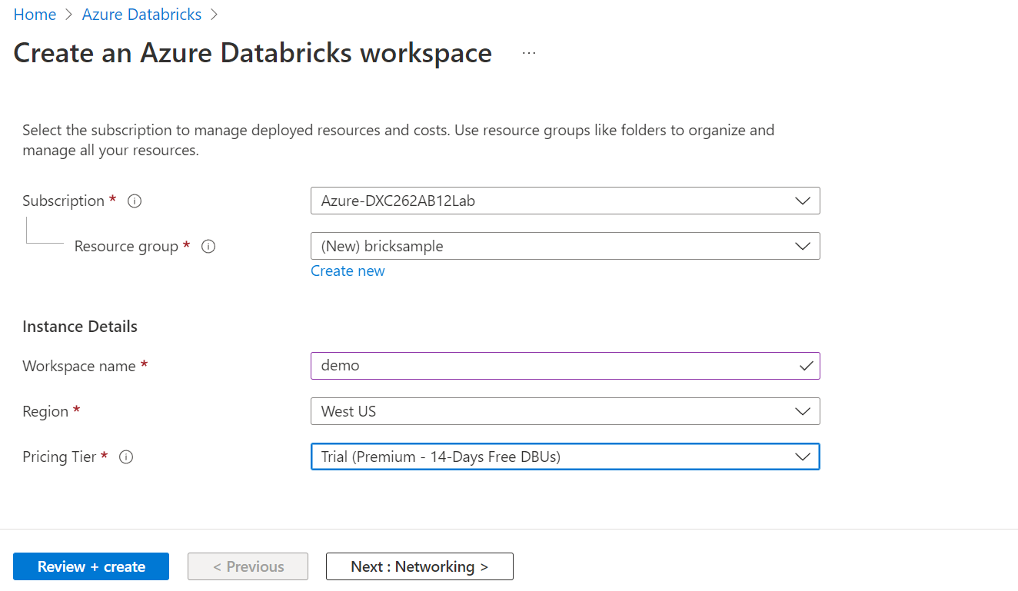

After click on the review+ create deployment will be started which is like below.

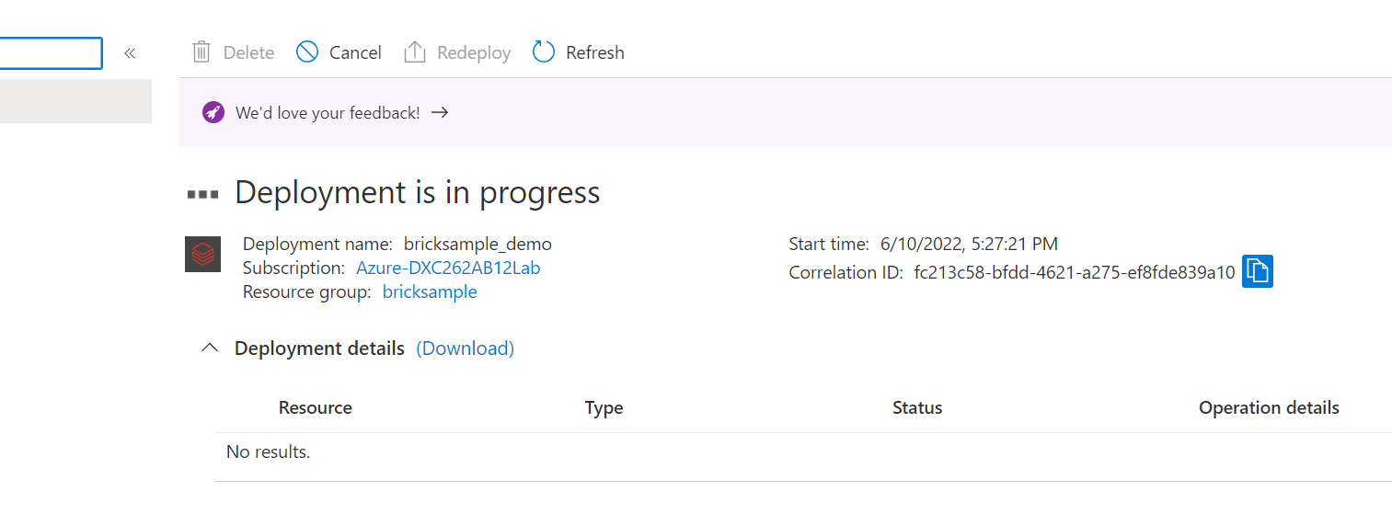

After completion of the deployment then click on the workspace. After that it will asking for any Microsoft account. Then choose one Microsoft account.

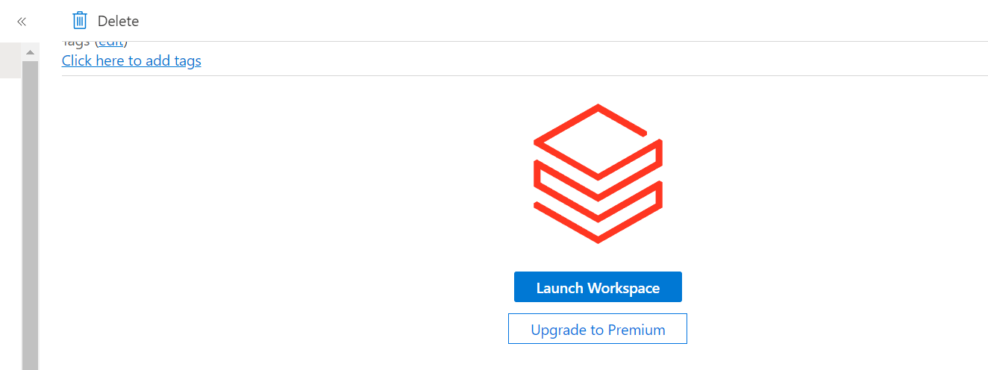

After entering into the data bricks the interface will be come like.

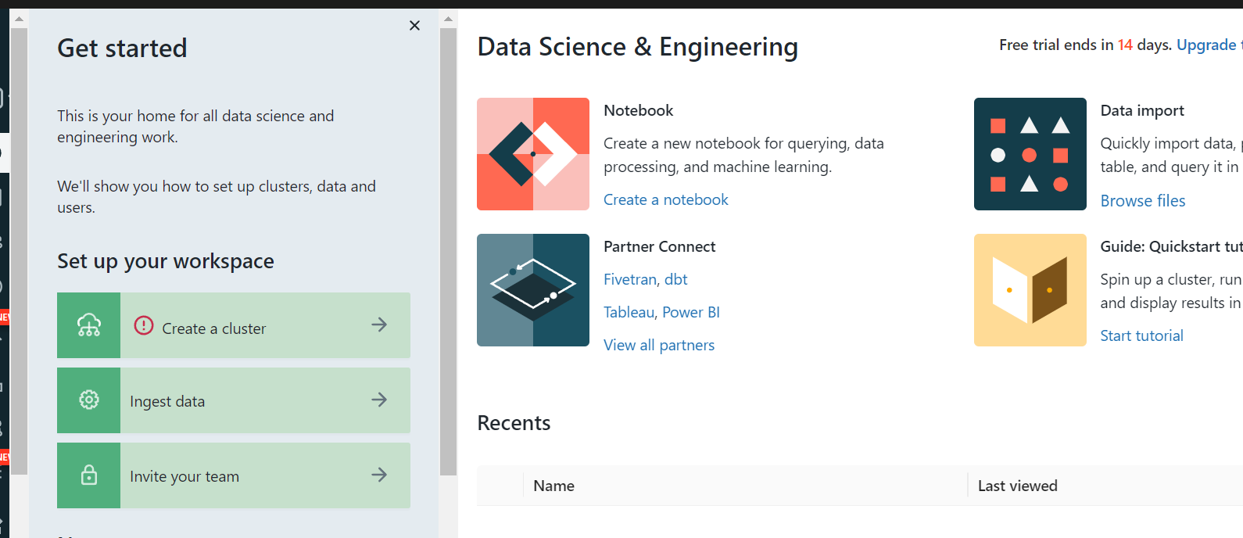

In data brick click on create >cluster> give the required information then create cluster.

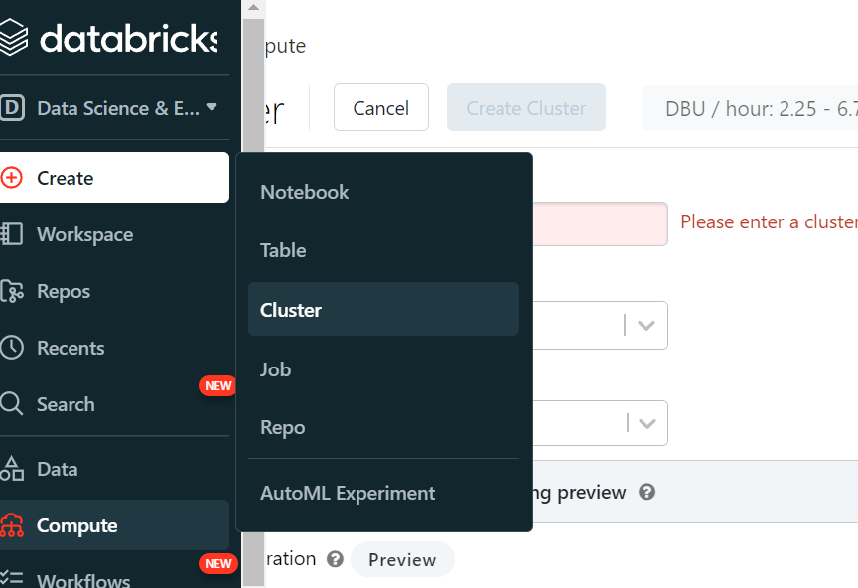

Click on the note book instead of the cluster and give any name to it.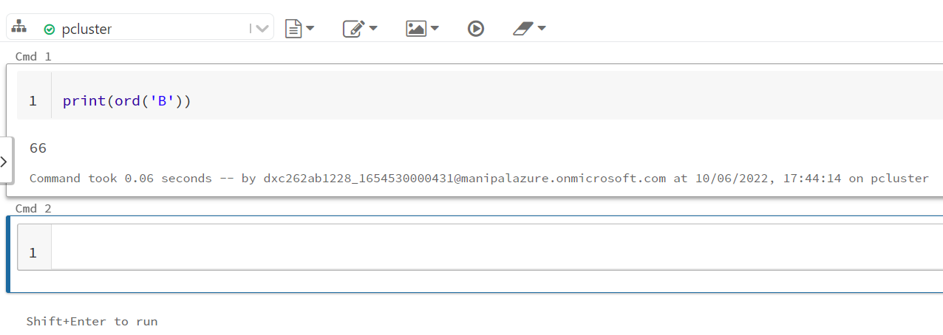

Create azure data factory by clicking on the create button

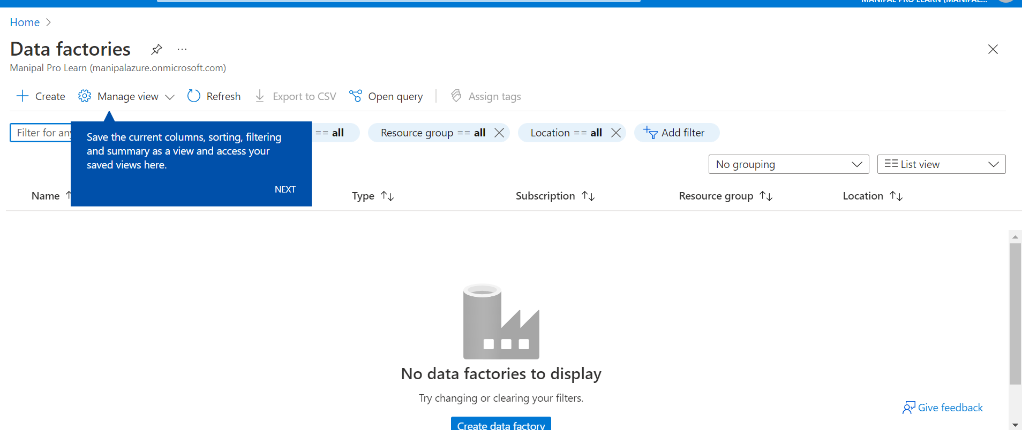

While creating the data factory we need to give the all necessary fields. Then validation is in progress.

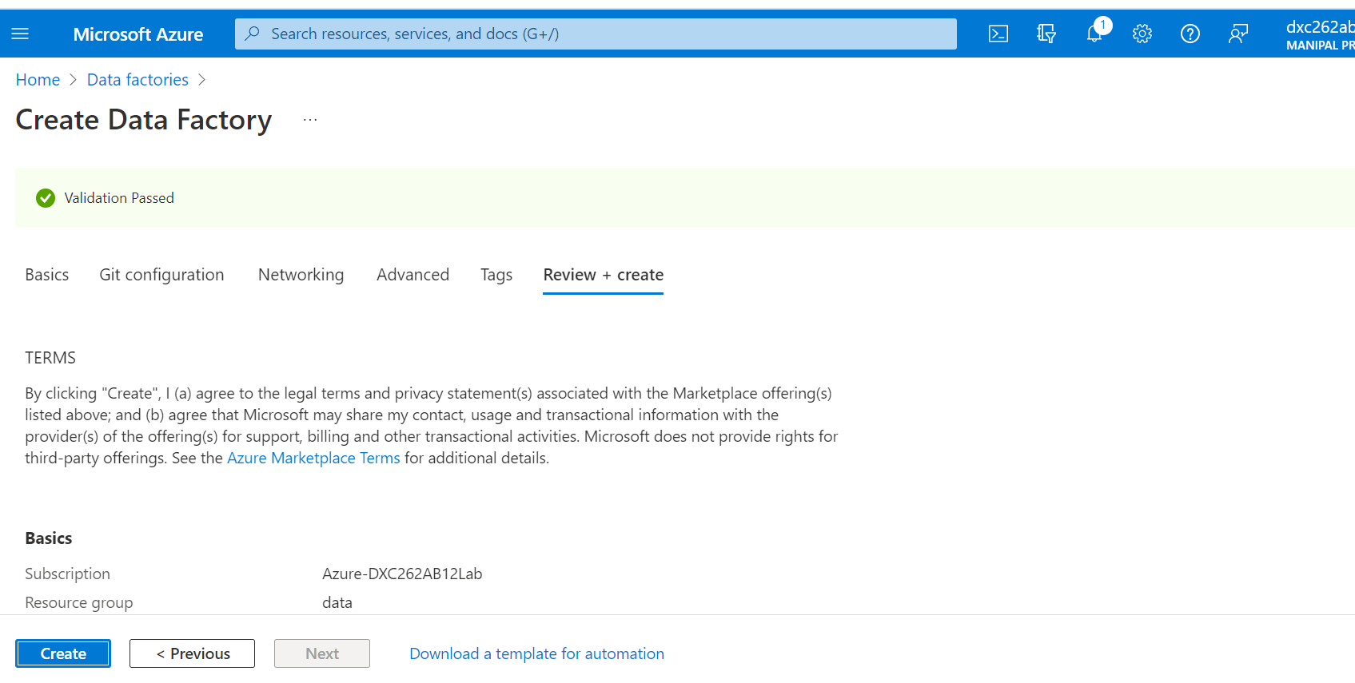

After completion of the validation deployment is created. Then go to resources

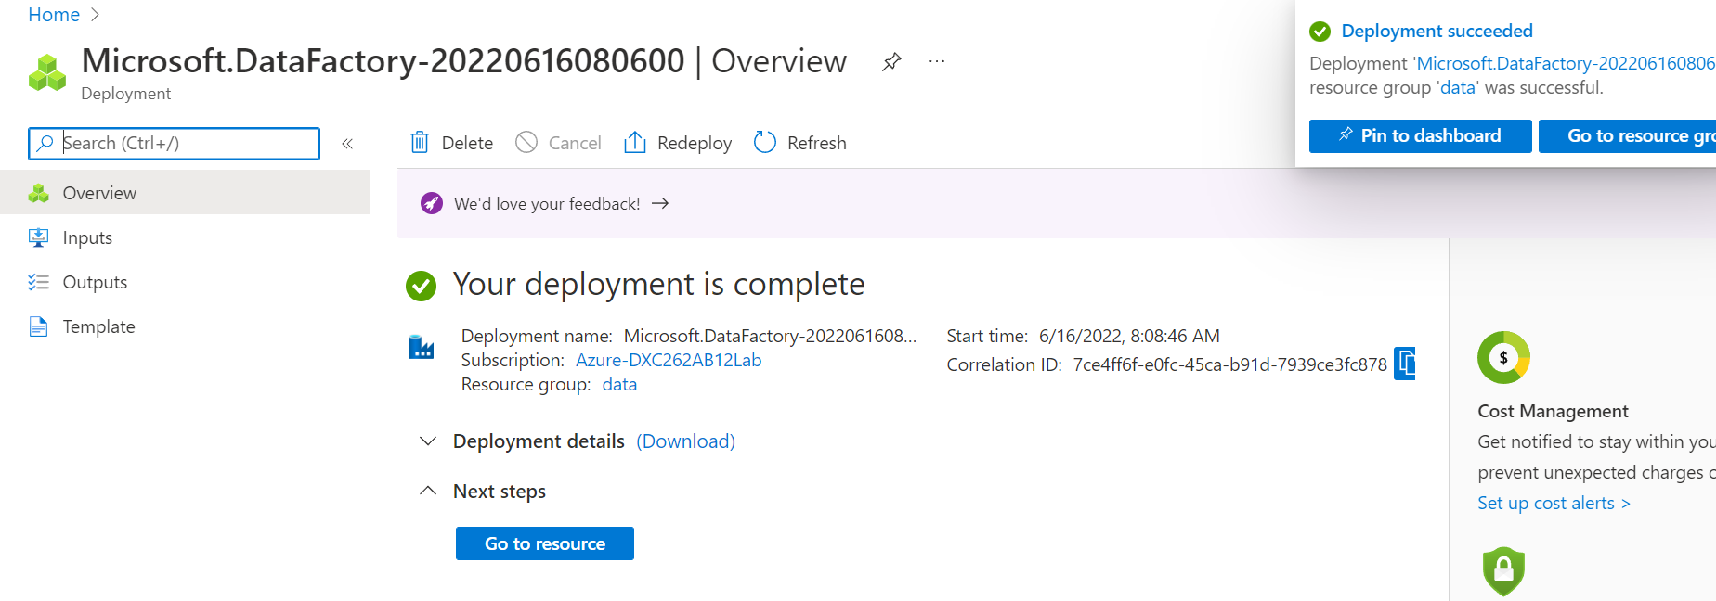

Now open the data factory studio.

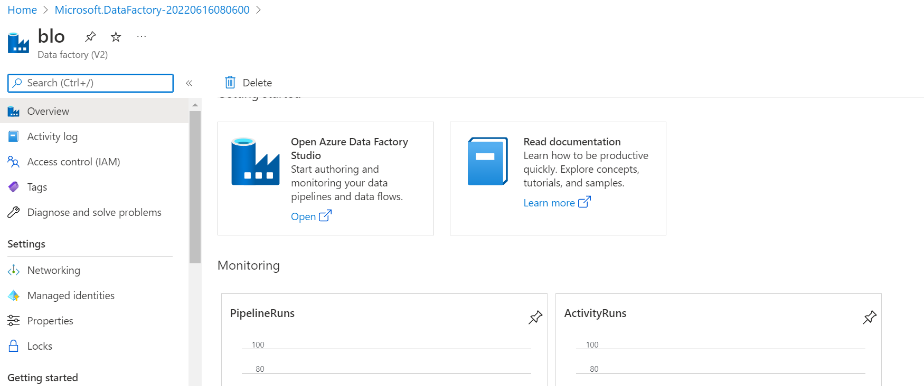

Here we need to create the pipe line to connect the data bricks note book.

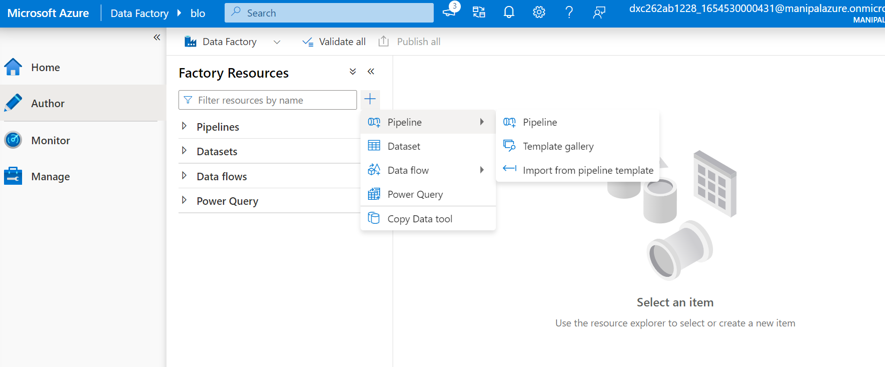

From the data bricks drag and drop the note book which is already created in the data bricks.

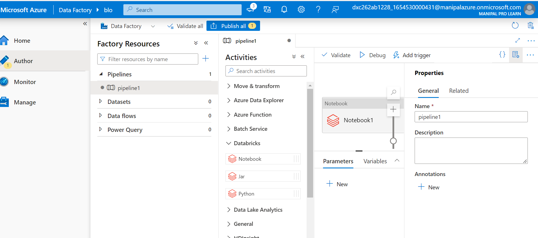

Generate the new access token and give the purpose of the token

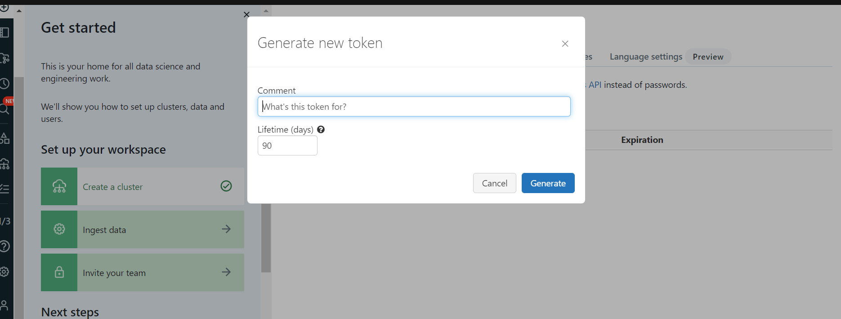

In the linked services give the all required fields with the access token.

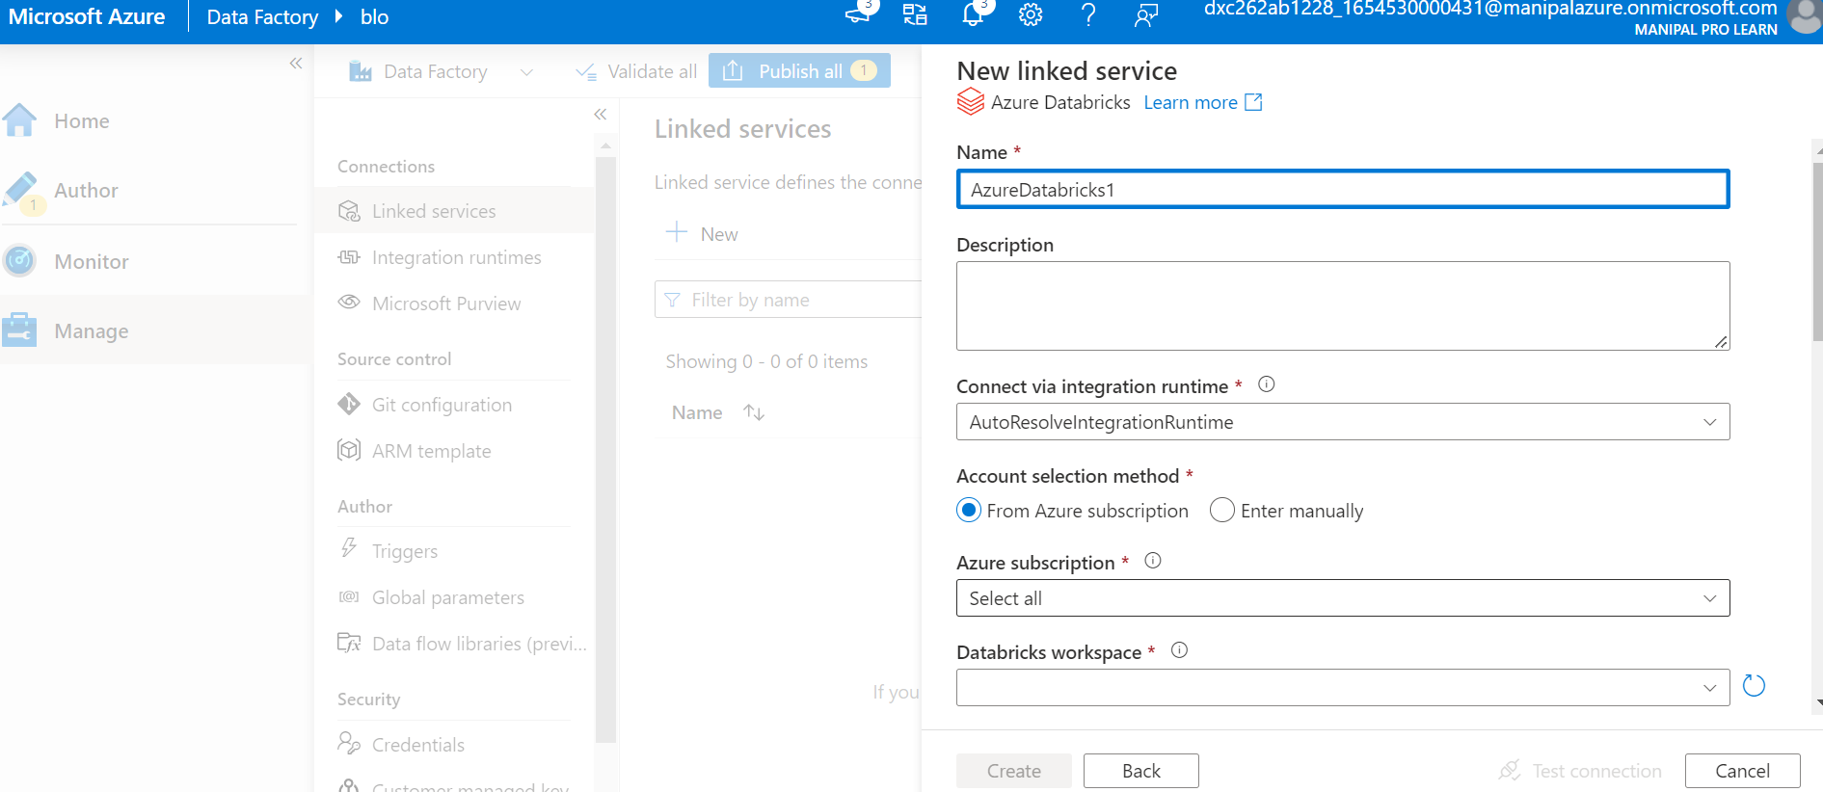

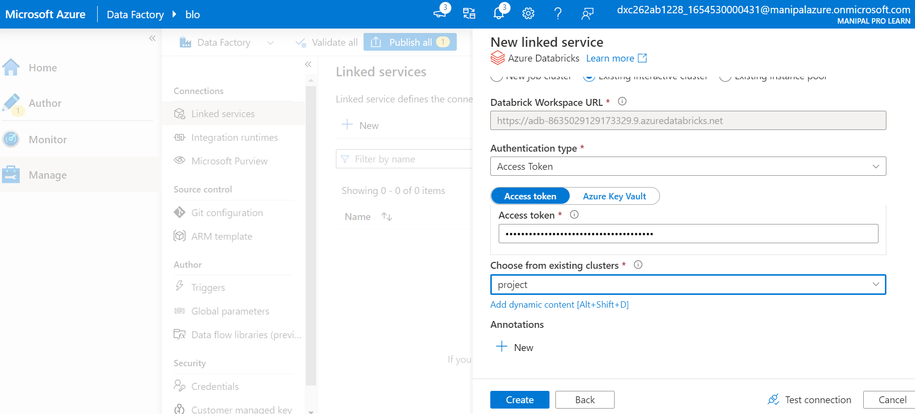

After creating the linked service

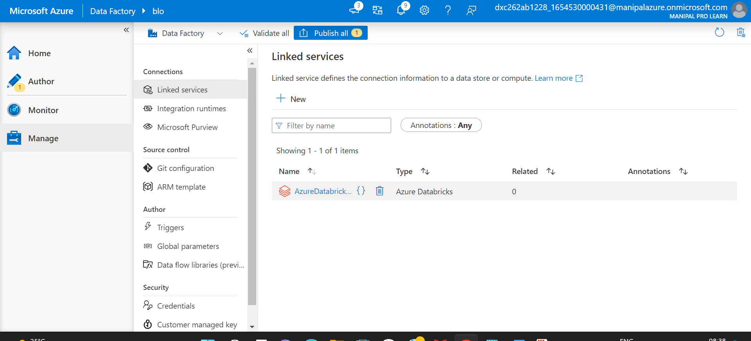

**Result:**

Successfully able to link the azure data brick notebook using data factory

**Conclusion:**

Azure data factory linked with the azure data brick note book